**CREATION OF BASE TABLES AND DML OPERATIONS**

* Create table my_employee(

ID number(4),

Last_name varchar (25)

First_name varchar(25),

userid varchar(25),

salary number(9,2)

);

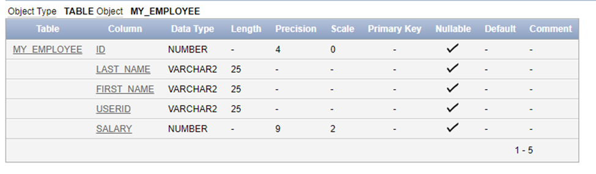

* Insert into my_employee values

(1, ‘patel’,’ralph’,’rpatel’,895),

(2,’dancs’,’betty’,’bdancs’,860),

(3,’Biri’,’Ben’,’bbri’,1100),

(4,’Newman’,’chad’,’Cnewman’,750);

* Select *from my_employee

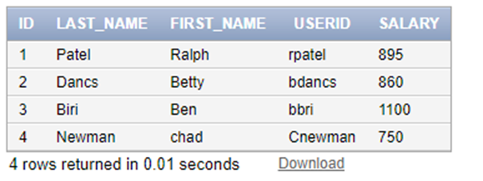

* delete from my_employee where first_name='Betty';

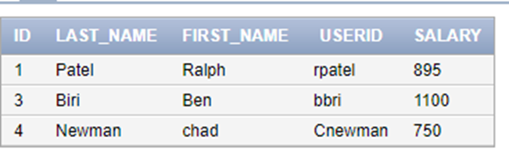

* delete from my_employee where ID=4;

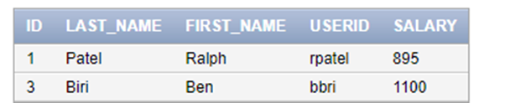

* commit;
* update my_employee set last_name='Drexler' where ID=3;

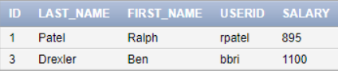

* update my_employee set salary=1000 where salary<900;

